Activity 5.1: Water state
Create a program where the user enters the temperature of some water in centigrade and the program tells them whether it is frozen, boiling or neither frozen nor boiling. Water boils at 100℃ and freezes at 0℃. For example:
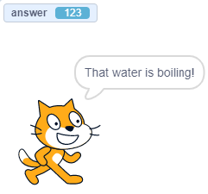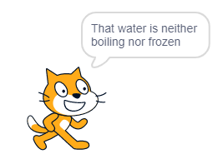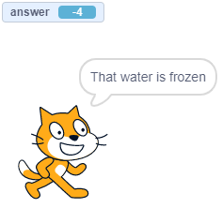
Temperature = 123℃ = boiling Temperature = 76℃ = Temperature = -4℃ = frozen
neither frozen nor boiling

You will need to use selection and will need to check more than one condition. Here is an example of a Scratch program that checks more than one condition:
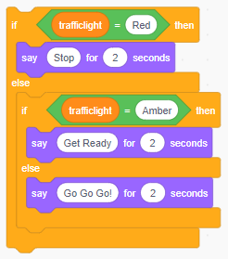
Don’t forget to screenshot your blocks and paste the screenshot into your evidence document.

